MACH4METAL

metalworking machinery
Transito 21, 6909 DA Babberich, Netherlands
Tel. + 31 (0)316 – 247123
Fax. + 31 (0)316 - 247956
info@mach4metal.com
www.mach4metal.com
Bank No : 66.52.13.883
IBAN : NL33 INGB 0665 2138 83
BIC : INGBNL2A
VAT : NL 815393635B01

ATLAS Shaping machine 750 mm

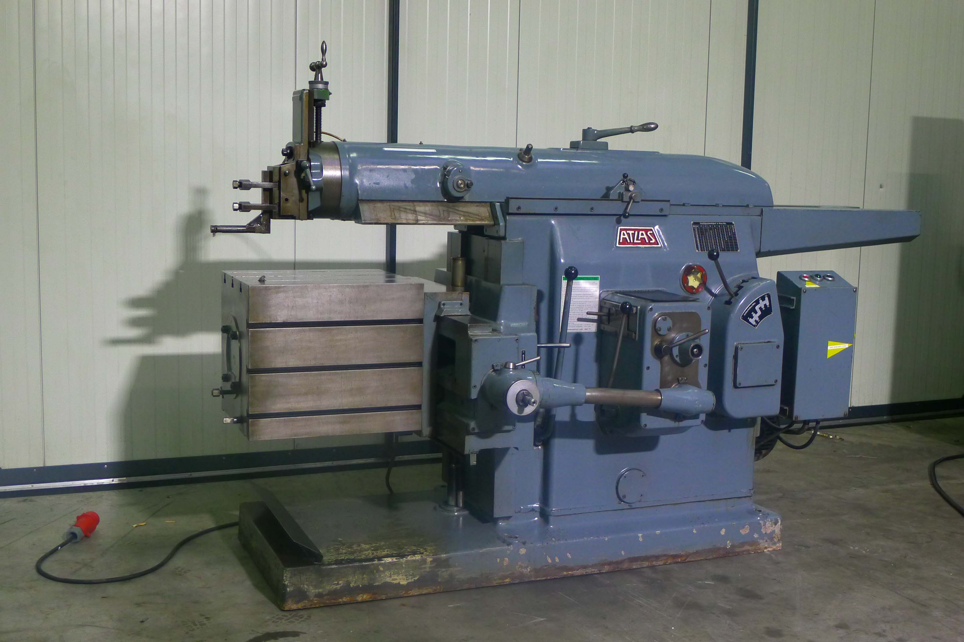
- Make : Atlas - Germany
- Typ : W 750
- Age : 70 er
- Mach.No. : AKK 90588

- Ram stroke : 750
- Travel X : 490
- Travel Y : 500

- T slotted table width : 560
- T slotted table depth : 480
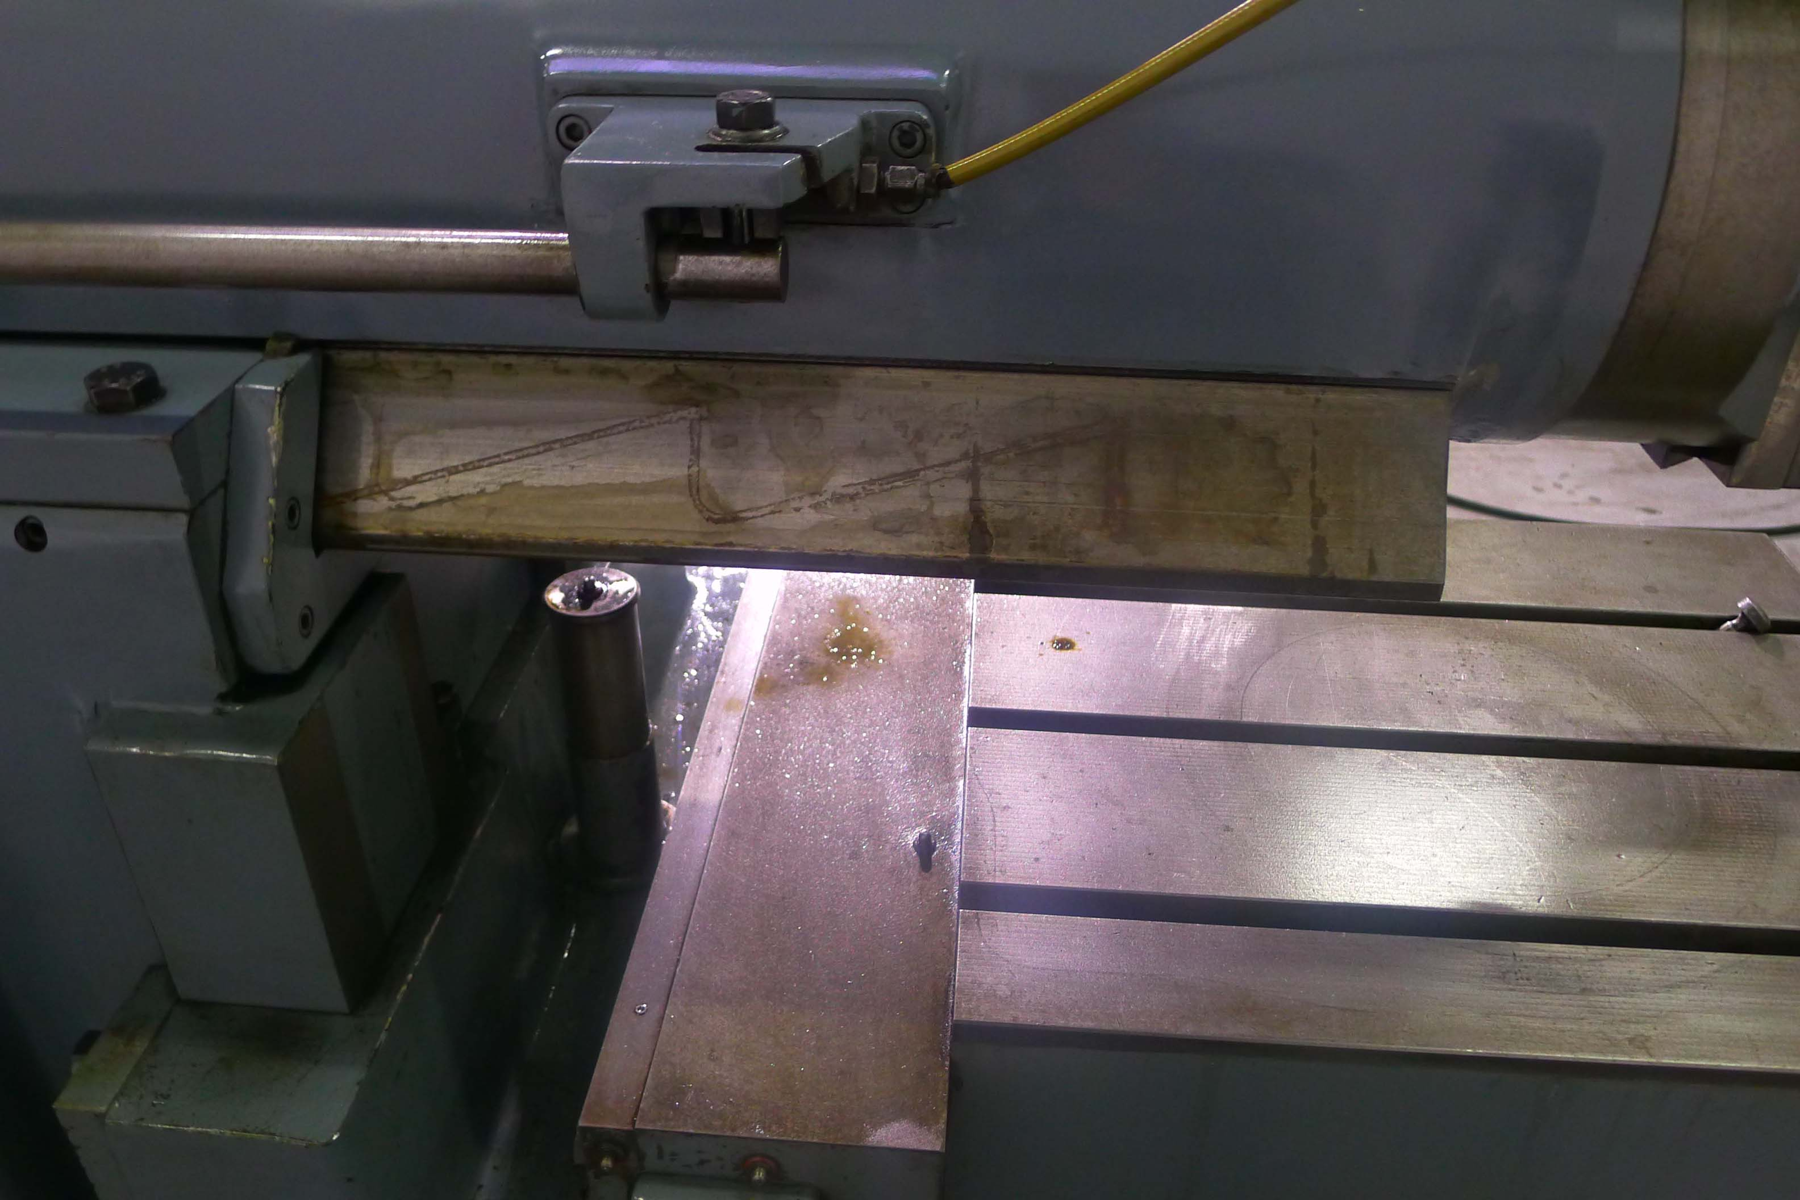
- T slotted table height : 500

- Stroke tool holder head : 175
- Rotation head – 60 to + 60 Gr.

- Stroke’s 0 – 700 mm
- Shaping speed 12 / 17 / 24 / 34
48 / 67 / 95 / 132 M/min.
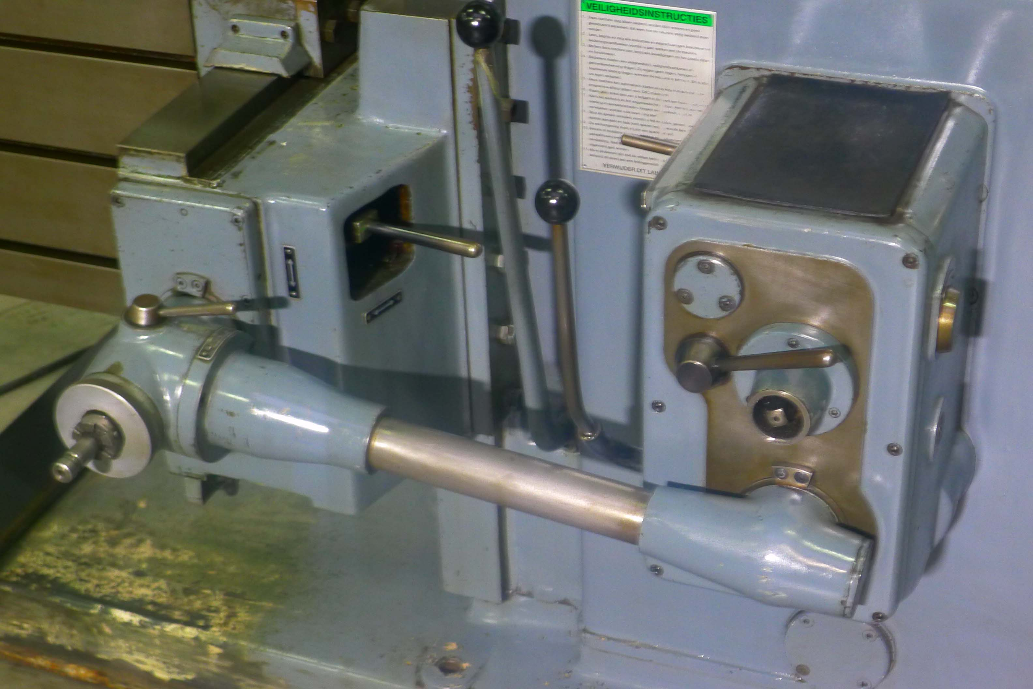
- Dimensions
- Length : 3.000
- Width : 1.800
- Height : 1.800
- Weight : 3000 Kg
- Power : 10 kW ?

- Auto feeds
- Very little used

Please Note: The above information has been obtained to the best of our ability and belief from, and from the manufacturers where possible. It is given in good faith, but its accuracy can not be guaranteed. Accordingly, it will not form a representation or constitute contractual terms. We advise you to check any vital details!

